PJT02780- CR&B-FO eServices
310.CRM 7

History of Changes

Rev. | Date | Modified by | Comments
1.0 | 06/23/2014 | Nair, Manoje | Initial Draft
1.1 | 06/23/2014 | Adepu, Srini | Added comments related to user profile check & updates in OKTA.
1.2 | 07/01/2014 | Lisa Compton | Business Review
1.3 | 07/01/2014 | Nair, Manoje | Added comments to address Lisa’s questions
1.4 | 07/02/2014 | Nair, Manoje | Added 310-04 to 310-06
 | 07/10/2014 | Lisa Compton | Business Review
1.5 | 07/23/2014 | Nair, Manoje | Updated with CSR-eBill Enrollment solution
!.6 | 07/31/2014 | Lisa Compton | Business Update

Business/Sponsor Requirements

More customers are leveraging the company’s online offerings to complete transactions and interact with Consumers Energy. eServices is visited over 1M times each month by customers to pay bills, report payments, create payment arrangements, enroll in payment plans, report power outages, report meter reads and transfer/start services. Those functions account for 77% of the total web related traffic.

In 2014, an eServices Replacement project was originated with the objective to increase our customer’s overall satisfaction with the company, and its interactions with us. JD Power will be the metric to determine success, additionally, meeting availability and performance metrics established with the company’s “get to good” efforts well set the target for project success.
- System availability and performance metrics
- System reliability and flexibility to respond to customer needs.
- Successful self-serve transaction completion and reduced call center traffic of related transaction types
- Improved customer experience and satisfaction ratings
- Improved JDPA scores

Stakeholder & Solution Requirements

Stakeholder & Solution Requirements
Rqmt ID | Description | Type
310-01 | CSR – Update Email Address, FN, LN from CRM | Like-for-like
310-02 | CSR – eBill Enrollment | Like-for-like
310-03 | CSR – Okta Admin Link from CRM and Desktop SSO | Like-for-like
310-04 | eBill view from CRM 7 | Like-for-like
310-05 | OPower link in CRM to generate SSO token via Portal/Okta | Like-for-like

Solution Details (i.e. Diagrams, Flows)
310-01 CSR – Update Email Address, First Name, Last Name from CRM:
- System of record for Customer Profile data will be SAP ECC
- Changes to profile attributes (email, FN, LN) in SAP ECC will be immediately pushed to Okta by ECC via PI and a .Net SOAP/REST wrapper call.
- CSR will interact with SAP ECC via CRM and Okta Admin page for Helpdesk role directly.
- CSR can update user attributes (FN, LN and Email) from CRM
- Any update in ECC on user attributes such as FN, LN and Email will be pushed to Okta
- CSR(BCC or BO) access Okta Administration module only for password reset and Account unlock/lock
  - eServices admin link will be available to user based on their business role (CSR 3, BO, VCC, BCC)
  - Business role will be determined by business team.
  - OPEN ITEM: Business (Lisa) is collecting list of all users that require access to the new Okta Admin Pages.

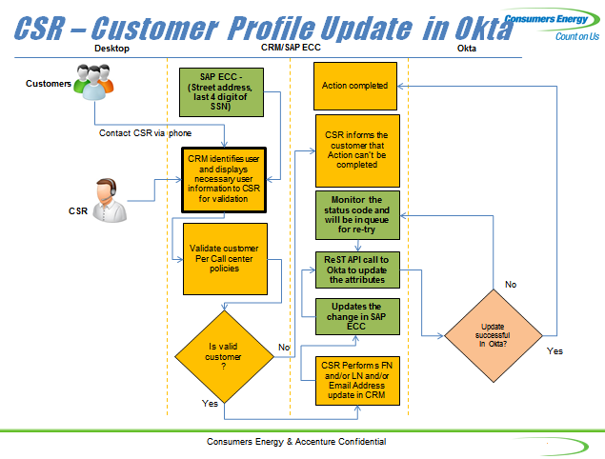

310-02 Changes to CSR eBill Enrollment Process (During CRM7 Move-In):

WS93000115 - Move In Workflow

All of the current eBill presentation functionality in the Move-in Workflow will be replaced with the screen(s) depicted below.

For customers with no email address:
Save
Customer Declined
Re-enter email address for validation.
Please provide your email address.

For customers with existing email address:
Step 1
Confirm
Change Email
johndoe@att.com
Re-enter email address for validation.
Please confirm your email address is…

Step 2
Save
Re-enter email address for validation.
Please provide your email address.

- If the customer does not want to supply an email address, the CSR will click the “Customer Declined” button and process will resume with the next step of the move in process. No updates will be made anywhere.
- If the customer does supply an email address, the CSR will confirm the email address by re-entering the email address. When CSR selects “save”, the two fields will be compared. If they match, the email address will be saved. If not, CSR will get an error and must correct to complete.

The email address will be checked for syntax and then pass update to ECC. Both the business partner independent and dependent email address will be updated (field references below).

The update on email address change in ECC will invoke Okta update function from ECC and push the update/change to Okta if the customer has an eServices profile.

A “Welcome to CE” email will be sent to all added email addresses through this process. Content of this email is TBD.

Note: If the customer has an existing eServices account, the update will replace the email address in Okta

310-03 CSR – Okta Admin Link from CRM and Desktop Single Sign On

- Single Sign On (SSO) is enabled via AD group
- CSR list need to be added manually to AD group based on predetermined AD roles
- AD group determine CSR access to CRM 7
- Once CSR login to CRM 7, business role will be displayed (CSR 3, BO, VCC, BCC)
- Links to Okta Admin page for Help Desk Role will be displayed only to CSR with specific roles in CRM (UME link will be replace with Okta Admin page). Link within CRM7 to Okta Admin tool will be called “Online Profile Management”.
- Desktop icon will be available to link to Okta Admin page for Help Desk Role but access is restricted based on AD group
- Okta Desktop SSO configuration enables SSO functionality

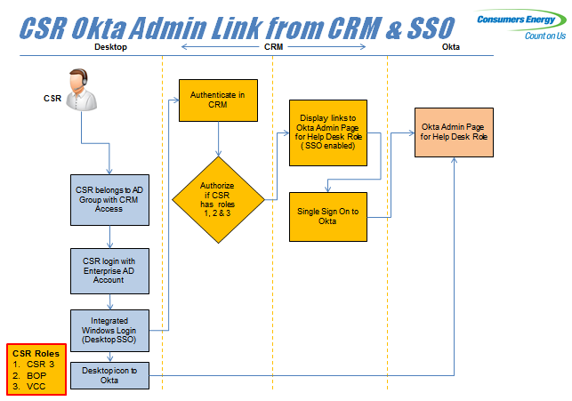

310-04 eBill view from CRM 7

- This solution enables CSR to view eBill from ISIS
- CSR to select Customer contract number and print document number from CRM and send the information directly to ISIS to generate eBill
- The pdf request will not pass through Okta as it currently passes through UME
- eBill is generated in PDF format from ISIS and sent to CRM for rendering
- PDF will be displayed in pop-up window
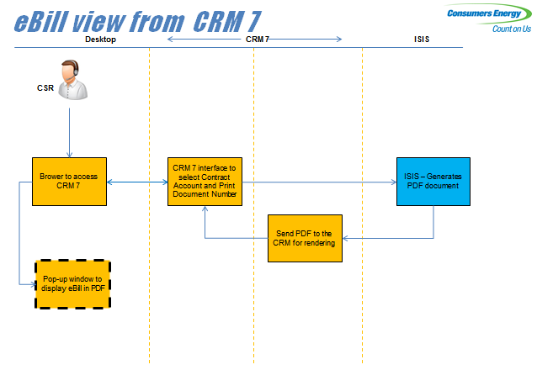

310-05 OPower link in CRM to generate SSO token via Portal/Okta

- This solution allows CSRs to access OPower quickly from CRM 7 (CRM Web IC) interface allowing them to rapidly retrieve a customer account in the Opower CSR Portal for advanced customer support.
- After the CSR has confirmed the BP and contract account they will launch OPower by clicking on the Launch OPower link in their navigation bar.
- The contract account/premise information from CRM 7 will be passed via secured URL to enable the population of the OPower search field.
- SAML token is being generated at Portal / Okta for Single Sign-On action with OPower and will be transparent to CSRs
- A new window will open and the OPower information will be displayed
- Access to SSO service in Portal/Okta is restricted to CSR’s desktop IP addresses

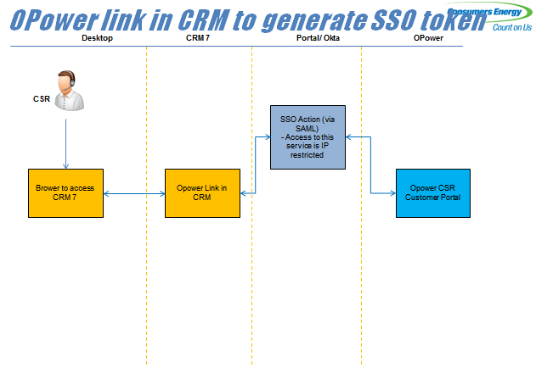

Data Requirements & Mapping

Okta/SAP
Field Name | SAP Table/Field | Length | Format | Notes/Rules
First Name | BUT000-NAME_FIRST | 50 | String | Changes in SAP field will be updated in Okta real time
Last Name | BUT000-NAME_LAST | 50 | String | Changes in SAP field will be updated in Okta real time
Email address | ADR6-STMP_ADDR | 255 | String | Changes to SAP address dependent and independent email fields will be updated in Okta real time
First Name (Business BP) | BUT000-Name_org2 | 50 | String | Changes in SAP field will be updated in Okta real time
Last Name (Business BP) | BUT000-Name_org1 | 50 | String | Changes in SAP field will be updated in Okta real time

Testing Scenarios
CSR3 updates BP dependent email address
CSR3 updates BP independent email address
CSR3 updates both BP dependent and independent email address
CSR3 updates BP first name
CSR3 updates BP last name
CSR3 updates SSN
CSR3 updates DL
BO updates BP dependent email address
BO updates BP independent email address
BO updates both BP dependent and independent email address
BO updates BP first name
BO updates BP last name
VCC Management updates BP dependent email address
VCC Management updates BP independent email address
VCC Management updates BP first name
VCC Management updates BP last name
VCC Management updates both BP dependent and independent email address
BCC updates BP dependent email address
BCC updates BP independent email address
BCC updates both BP dependent and independent email address
BCC updates BP first name
BCC updates BP last name
BCC updates SSN
BCC updates DL
BCC Management enters email address correctly formatted email address during email
BCC Management skips entering an email address
BCC Management enters email address incorrectly formatted email address
BCC Management logs into Okta via desktop icon
BCC Management generates PW reset link in Okta
BCC Management unlocks eServices account in Okta
CSR2 enters email address correctly formatted email address during email
CSR2 skips entering an email address
CSR2 enters email address incorrectly formatted email address
CSR3 enters email address correctly formatted email address during email
CSR3 skips entering an email address
CSR3 enters email address incorrectly formatted email address
VCC Management enters email address correctly formatted email address during email
VCC Management skips entering an email address
VCC Management enters email address incorrectly formatted email address
VCC Management logs into Okta via desktop icon
VCC Management generates PW reset link in Okta
VCC Management unlocks eServices account in Okta
BO logs into Okta via desktop icon
BO generates PW reset link in Okta
BO unlocks eServices account in Okta
CSR3 logs into Okta via desktop icon
CSR3 generates PW reset link in Okta
CSR3 unlocks eServices account in Okta
CSR1 launches bill pdf from CRM
CSR2 launches bill pdf from CRM
CSR3 launches bill pdf from CRM
VCC Management launches bill pdf from CRM
BCC launches bill pdf from CRM
BO launches bill pdf from CRM
CSR1 launches OPower link from CRM
CSR2 launches OPower link from CRM
CSR3 launches OPower link from CRM
VCC Management launches OPower link from CRM
BO launches OPower link from CRM
BCC launches OPower link from CRM
CRM7 MI Customer Declines eBill
CRM7 MO customer not enrolled on eBill
CRM7 MI enrolls on eBill existing e-mail address not enrolled on eServices successful
CRM7 MI enrolls on eBill no e-mail address on file successful
CRM7 MI enrolls on eBill existing e-mail addresses not enrolled on eServices don't match
CRM7 MI enrolls on eBill no e-mail address on file; 2nd address doesn't match
CRM7 MI enrolls on eBIll existing e-mail address not enrolled on eServices changed successful
CRM7 MI enrolls on eBill existing e-mail address changed not enrolled on eServices 2nd address doesn't match

CRM7 MI enrolls on eBill existing e-mail address enrolled on eServices successful
CRM7 MI enrolls on eBill existing e-mail addresses enrolled on eServices don't match
CRM7 MI enrolls on eBIll existing e-mail address changed enrolled on eServices successful
CRM7 MI enrolls on eBill existing e-mail address changed enrolled on eServices 2nd address doesn't match

